## Simple SOAP UI web services project with WSDL

Problem Statement-:

* Take any WSDL from the project or from public domain

http://zero.webappsecurity.com/web-services/infoService?wsdl

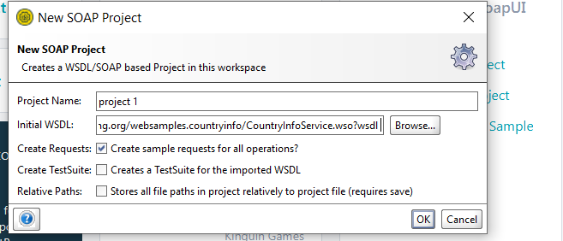

* Identify endpoint based on the input created.

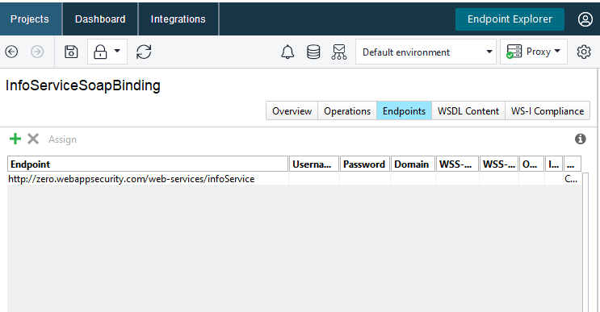

**Construct input and output xml**

OUTPUT XML

INPUT XML

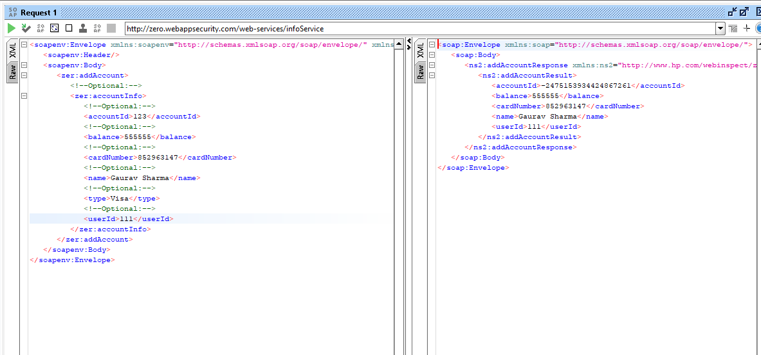

OUTPUT XML

INPUT XML

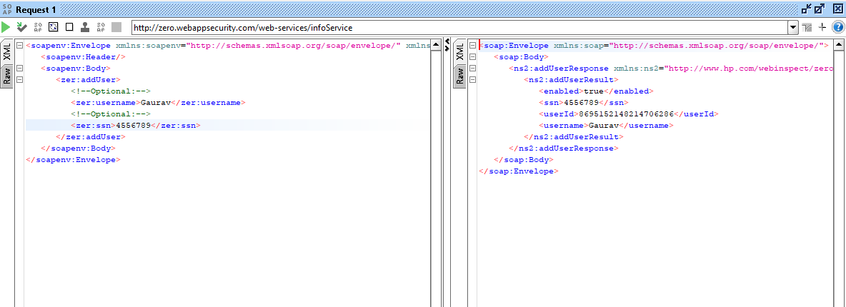

OUTPUT XML

INPUT XML

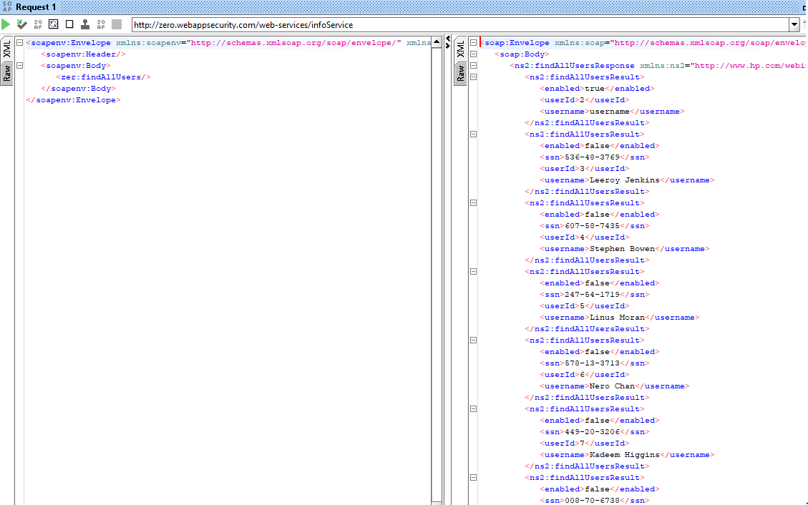

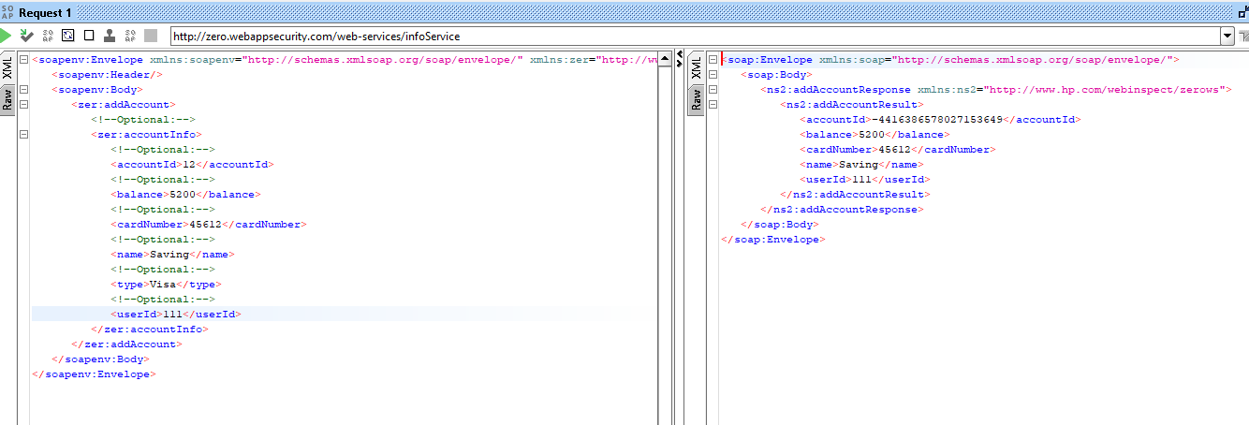

OUTPUT XML

INPUT XML

* **Modify the WSDL to reinforce understanding**

ORIGINAL INFOSERVICE WSDL FILE

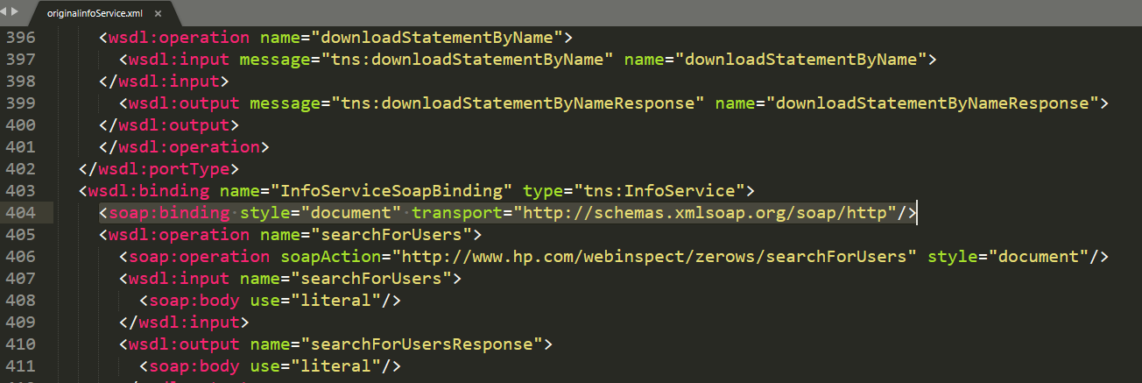

MODIFY INFOSERVICE WSDL FILE

